At Plunkett, every member counts. Our diverse network of members directly informs and shapes all aspects of the support we provide and enables us to champion the community business sector with policy makers, funders and the media. Through vibrant community-owned businesses we help to tackle the issues of isolation, loneliness, wellbeing, employment and training.
In the last 12 months, we've experienced an unprecedented number of enquiries and requests for support from community groups across the UK looking to establish community businesses, or seeking support to make sure existing businesses remain viable. We're anticipating that demands on our service will only increase in 2021, so have ambitions to grow our network of supporters, to increase our capacity to provide practical support and advice, and to further the work we’re doing to advocate for the community business sector – but we need your help!
Member get member scheme
We’re asking you to encourage your contacts, members, customers, shareholders and communities to become individual supporters of Plunkett for just £20 per year. The first 10 members to recruit 10 or more individual supporter members will receive a free place on a Plunkett training course (up to the value of £100).This resource pack is designed to give you some ideas of how to talk about supporter membership and the member get member scheme, to help Plunkett to grow our network and recruit new supporter members, so we can continue to provide practical advice and guidance to community businesses across the UK. It is made up of two sections:

- Templates for community businesses
  - Sample email/newsletter text
  - Sample social media posts and accompanying graphics

- Templates for existing supporter members
  - Key messages – how to talk about supporter membership
  - Sample social media posts and accompanying graphics

If you have any queries about the member get member scheme, more information is available on our website or contact membership@plunkett.co.uk

Section 1: For community businesses
Sample email/newsletter text

As you know <Name of Community Business> is owned by the community, run by the community, and strives to support the community in a variety of ways. We, and more than 700 other community businesses across the UK, have benefited from practical support and advice from a national charity called the Plunkett Foundation, whose mission is to inspire and empower rural communities to work together to find solutions to their needs through sustainable community enterprise.
In the wake of the Covid-19 pandemic, the Plunkett Foundation have received more enquiries than ever before. In order to continue to help community businesses like ours, they need your support. If you’re passionate about communities and community business, please join Plunkett as a supporter member. We’re taking part in Plunkett’s member get member scheme, which means that if our membership number is quoted 10 times, we could receive a free place on a Plunkett Foundation training course – so by helping them, you’re helping us.
Supporter membership costs just £20 per year, and by becoming an individual supporter, you are directly contributing to the work Plunkett does to help communities establish and run community businesses. Benefits include:
- Access to member-only events and networking opportunities – including voting rights at the Annual General Meeting – as well as discounts on Plunkett’s training hub events
- Member alerts to keep you up to date on Plunkett’s news, and member-specific notifications of Plunkett’s publications, consultations and reports
- Access to a Google maps list of community businesses across the UK, so you can support local, wherever you are
Joining online is quick and easy – just complete this form and please remember to quote our membership number <membership number> when asked.
You can find out more about the Plunkett Foundation at www.plunkett.co.uk
Thank you for your continued support!

Template social media posts

Twitter
We, and more than 700 other community businesses, have benefited from support given by UK-wide charity @PlunkettFoundat. Help them to help us by becoming a £20 supporter member, and we'll be in with the chance of receiving free training! Sign up here: http://bit.ly/supportplunkett
Facebook
Alongside 700 other community businesses, we have benefited from support given by UK-wide charity the @plunkettfoundation. We are taking part in their member-get-member scheme and need your help! If you sign up as a supporter member for £20 a year, we are in with a chance of receiving free training – so by helping them, you’re helping us. http://bit.ly/supportplunkett
LinkedIn or Instagram
We have benefited from community business support given by UK-wide charity the Plunkett Foundation. Help them to help us by becoming a £20 supporter member, which will put us in with the chance of receiving free training! Sign up here: http://bit.ly/supportplunkett

Social media graphics
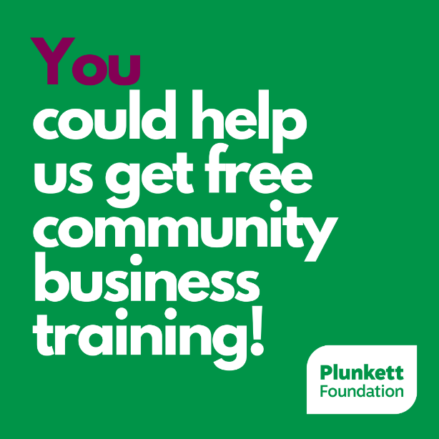

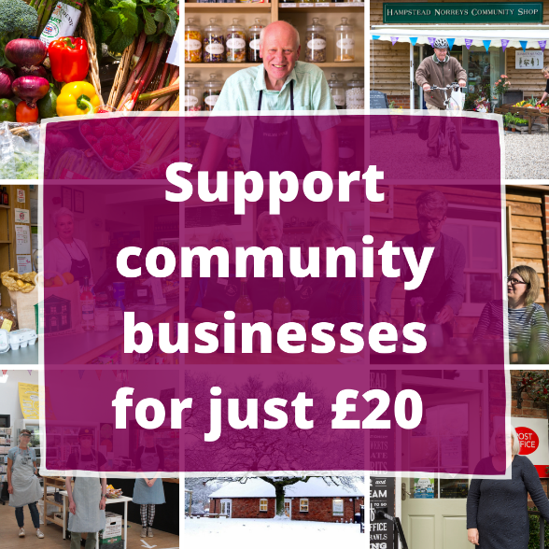

Section 2: For existing supporters
Key messages: How to talk about Plunkett and supporter membership

- Plunkett Foundation is a national charity advocating for and supporting communities across the UK to take ownership of their local assets, and establish and run community-owned pubs, shops, farms, bakeries, and more.
- More than 700 community businesses across the UK have benefited from practical support and advice from Plunkett.
- In the wake of Covid-19, the Plunkett Foundation has received more enquiries than ever before. In order to continue to help community businesses, they need your support.
- If you’re passionate about communities and community business, join Plunkett as a supporter member.
- Supporter membership costs just £20 per year, and by becoming an individual supporter, you are directly contributing to the work Plunkett does to help communities establish and run community businesses.
- At Plunkett, every member matters – it is the network of members that enables them to influence and advocate for community businesses with policy makers, funders, and the media.
- Benefits of supporter membership include:
  - Access to membership events and networking opportunities – including voting rights at the AGM – and discounts on Plunkett’s webinars and training course
  - Member alerts to keep you up to date on Plunkett and sector news
  - Member specific notifications of Plunkett’s publications, consultations and reports
  - Access to a Google maps list of community businesses, so you can support local businesses, wherever you are
- Joining online is quick and easy – just complete this form and please remember to quote my name or membership number <membership number> when asked.

Sample social media posts

Twitter

If like me, you believe in the power of communities and would like to see more shops, pubs, farms, woodlands, bakeries and breweries (and much more!) in community ownership, become a Plunkett supporter for just £20 a year:
http://bit.ly/supportplunkett

Facebook
If, like me, you like the sound of more pubs, shops, breweries and woodlands (and much more!) being community owned, then you can join me in becoming a Plunkett supporter member for just £20 a year. @plunkettfoundation help communities across the UK save and create community businesses, bringing people together and making local lifelines. http://bit.ly/supportplunkett

LinkedIn or Instagram
If, like me, you like the sound of more pubs, shops, breweries and woodlands (and much more!) being community owned, then you can join me in becoming a Plunkett supporter member for just £20 a year. Plunkett Foundation help communities across the UK save and create community businesses, bringing people together and making local lifelines. http://bit.ly/supportplunkett
If you have any questions about the member get member scheme or your own membership, contact us on membership@plunkett.co.uk

Social media graphics

